|  |  |
| --- | --- |
| Course Name | ITD 2313 – Script Programming |
| Instructor | Mark L. Pranger |
| Student Name | Thomas Webb |
| Due date | 7/22/2025 |
| Grade | Put grade earned here |
| Grading Comments | Put instructor comments here |

Page 191

192 & 193

Page 194

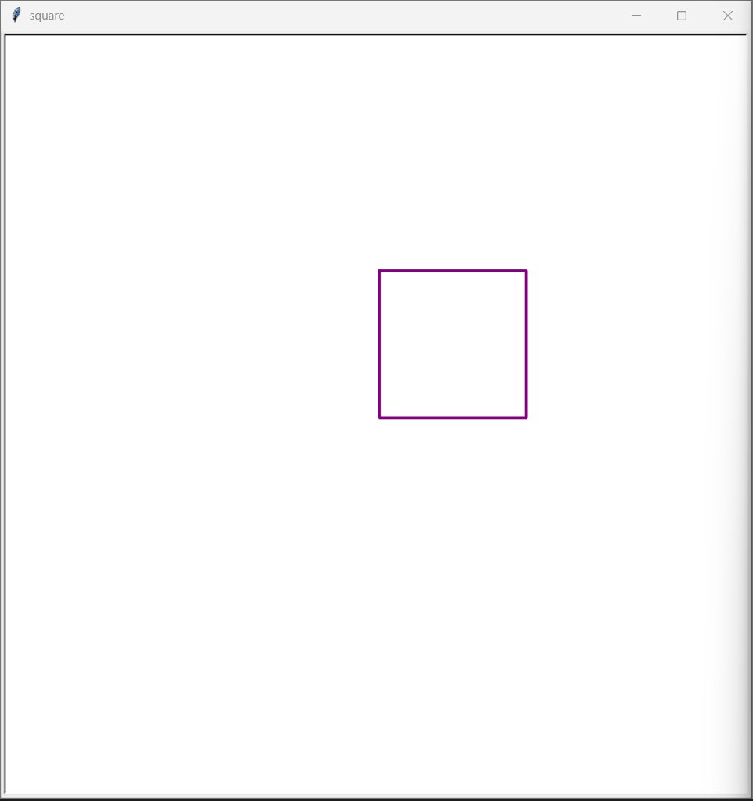



Page 195 - 197

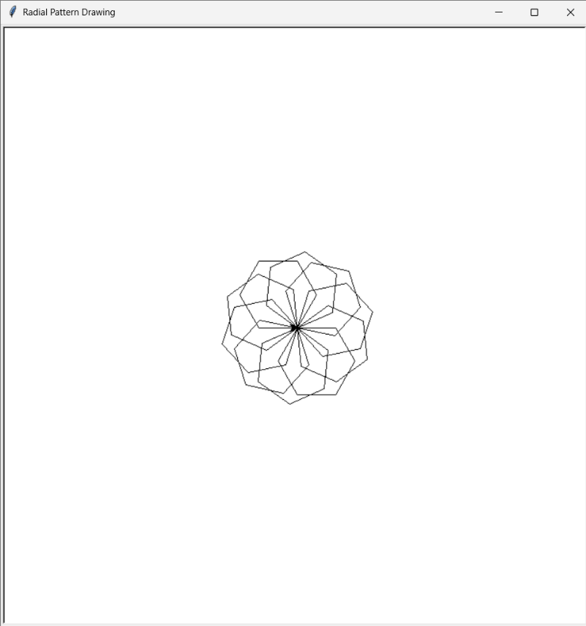

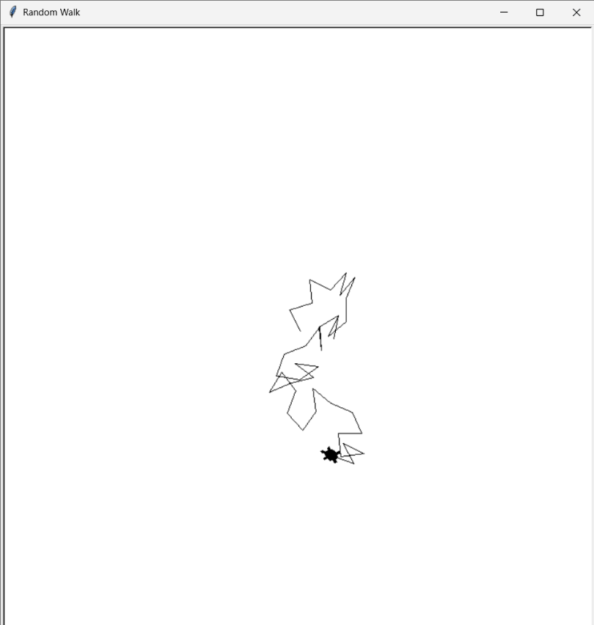

Page 206

Cannot do other pages due to error of the images not being able to be Pulled up